Chapter 1: The nature of software and introduction to software engineering
What is software engineering: is the application of systematic, discipline, quantifiable approach to the development, operations and maintenance of software; that is the application of engineering to software. The foundation of software engineering is the process layer.

Two factors that makes a software fail:
- Increased system complexity: As new software engineering techniques help us
- to build larger, more complex systems, the demands change.
- Failure to use software engineering: It is fairly easy to write computer programs without using software engineering methods and techniques.
Software engineering techniques and methods:
- Agile methodologies (Scrum and Kanban),
- Version control systems (like Git),
- Test-Driven Development (TDD),
- Continuous Integration/Continuous Deployment (CI/CD),
- Design patterns, code reviews, and documentation

Professional software development
A system may consist of several separate programs and configuration files that are used to set up these programs. It may include system documentation, which describes the structure of the system, user documentation, which explains how to use the system, and websites for users to download recent product information.

There are two kinds of software products:
- Generic products: These are stand-alone systems that are produced by a development organization and sold on the open market to any customer who is able to buy them.
- Customized (or bespoke) software: These are systems that are commissioned by and developed for a particular customer. A software contractor designs and implements the software especially for that customer.
The critical distinction between these types of software is that, in generic products, the organization that develops the software controls the software specification. This means that if they run into development problems, they can rethink what is to be developed. For custom products, the specification is developed and controlled by the organization that is buying the software. The software developers must work to that specification.

Software engineering
Software engineering is an engineering discipline that is concerned with all aspects of software production from the early stages of system specification through to maintaining the system after it has gone into use.

Essential attributes of a good software:
- Acceptability
- Dependability and security
- Efficiency
- Maintainability

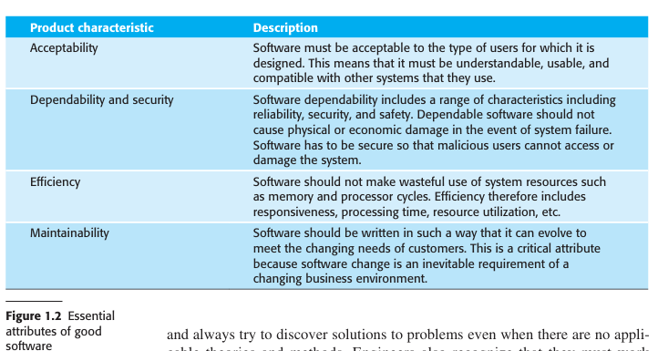

Software engineering is important for two reasons:
- More and more, individuals and society rely on advanced software systems. We need to be able to produce reliable and trustworthy systems economically and quickly.
- It is usually cheaper, in the long run, to use software engineering methods and techniques for professional software systems rather than just write programs as a personal programming project. Failure to use software engineering method leads to higher costs for testing, quality assurance, and long-term maintenance.

A software process is a sequence of activities that leads to the production of a software product. Four fundamental activities are common to all software processes:
- Software specification, this is where the engineer and customer define the software that is to be produced and the constraints to its operations.
- Software development, this is where the software is designed and programmed.
- Software validation, this is where the software is checked to ensure that the software meet the customer’s requirements.
- Software evolution, this is where the software is modified to reflect changing customer and market requirements.

Software engineering diversity
Software engineering is a systematic approach to the production of software that takes into account practical cost, schedule, and dependability issues, as well as the needs of software customers and producers. The specific methods, tools, and techniques used depend on the organization developing the software, the type of software, and the people involved in the development process.
Types of applications:
- Stand-alone applications These are application systems that run on a personal computer or apps that run on a mobile device. They include all necessary functionality and may not need to be connected to a network.
- Interactive transaction-based applications These are applications that execute on a remote computer and that are accessed by users from their own computers, phones, or tablets. Obviously, these include web applications such as e-commerce applications where you interact with a remote system to buy goods and services.
- Embedded control systems These are software control systems that control and manage hardware devices.
- Batch processing systems These are business systems that are designed to pro cess data in large batches. They process large numbers of individual inputs to create corresponding outputs. Examples of batch systems are periodic billing systems, such as phone billing systems, and salary payment systems.
- Data collection and analysis systems Data collection systems are systems that collect data from their environment and send that data to other systems for pro cessing. The software may have to interact with sensors and often is installed in a hostile environment such as inside an engine or in a remote location.
- Systems of systems These are systems, used in enterprises and other large organizations, that are composed of a number of other software systems. Some of these may be generic software products, such as an ERP system. Other systems in the assembly may be specially written for that environment.

Nevertheless, there are software engineering fundamentals that apply to all types of software systems:
- They should be developed using a managed and understood development process. The organization developing the software should plan the development process and have clear ideas of what will be produced and when it will be completed.
- Dependability and performance are important for all types of system. Software should behave as expected, without failures, and should be available for use when it is required. It should be safe in its operation and, as far as possible, should be secure against external attack. The system should perform efficiently and should not waste resources.
- Understanding and managing the software specification and requirements (what the software should do) are important. You have to know what different customers and users of the system expect from it, and you have to manage their expectations so that a useful system can be delivered within budget and to schedule.
- You should make effective use of existing resources. This means that, where appropriate, you should reuse software that has already been developed rather than write new software.

These fundamental notions of process, dependability, requirements, management, and reuse are important themes of this book.

Internet software engineering
The advent of the web has led to a dramatic change in the way that business software is organized. Before the web, business applications were mostly monolithic, single programs running on single computers or computer clusters. Communications were local, within an organization. Now, software is highly distributed, sometimes across the world. Business applications are not programmed from scratch but involve extensive reuse of components and programs.
This change in software organization has had a major effect on software engineering for web-based systems. For example:
- Software reuse has become the dominant approach for constructing web-based systems. When building these systems, you think about how you can assemble them from preexisting software components and systems, often bundled together in a framework.
- It is now generally recognized that it is impractical to specify all the requirements for such systems in advance. Web-based systems are always developed and delivered incrementally.
- Software may be implemented using service-oriented software engineering, where the software components are stand-alone web services.
- Interface development technology such as AJAX (Holdener 2008) and HTML5 (Freeman 2011) have emerged that support the creation of rich interfaces within a web browser.

Software engineering ethics
Software engineering ethics focuses on the responsible development and deployment of software, considering its impact on users, society, and the environment. It involves adhering to professional codes, navigating ethical dilemmas, and understanding the consequences of unethical practices. Key aspects include protecting user privacy, ensuring fairness, and promoting public good.

However, there are areas where standards of acceptable behavior are not bound by laws but by the more tenuous notion of professional responsibility. Some of these are:
- Confidentiality You should normally respect the confidentiality of your employers or clients regardless of whether or not a formal confidentiality agreement has been signed.
- Competence You should not misrepresent your level of competence. You should not knowingly accept work that is outside your competence.
- Intellectual property rights You should be aware of local laws governing the use of intellectual property such as patents and copyright. You should be careful to ensure that the intellectual property of employers and clients is protected. Patents protect inventions, while copyright protects original works of authorship. Patents cover inventions like new products or processes, granting the inventor exclusive rights to make, use, and sell the invention for a set period. Copyright, on the other hand, protects creative expressions like books, music, and artwork, giving the creator exclusive rights to reproduce, distribute, and adapt their work.
- Computer misuse You should not use your technical skills to misuse other people’s computers. Computer misuse ranges from relatively trivial (game playing on an employer’s machine) to extremely serious (dissemination of viruses or other malware).

Professional societies and institutions have an important role to play in setting ethical standards. Organizations such as the ACM, the IEEE (Institute of Electrical and Electronic Engineers), and the British Computer Society publish a code of professional conduct or code of ethics. Members of these organizations undertake to follow that code when they sign up for membership. These codes of conduct are generally concerned with fundamental ethical behavior.

Core principles of software engineering ethics:
- Public Interest: Software engineers should prioritize the well-being of the public and act in the public interest.
- Client and Employer Interests: Software engineers should balance their professional obligations with the interests of their clients and employers, while still upholding public interest.
- Quality and Standards: Software engineers must strive to produce high-quality software that meets professional standards and specifications.
- Judgment and Integrity: Software engineers should maintain integrity and independence in their professional judgment and avoid conflicts of interest.

Key Ethical Considerations:
- Responsibility and Accountability: Developers are responsible for the potential consequences of their software, including its social and environmental impacts.
- Algorithmic Bias: Software engineers must be aware of and mitigate algorithmic bias, which can lead to discrimination and unfair outcomes.
- User Privacy: Protecting user data and ensuring privacy is a fundamental ethical responsibility.
- Security: Software engineers must prioritize security and prevent vulnerabilities that could compromise user safety or data.
- Fairness and Accessibility: Software should be designed to be inclusive and accessible to all users, regardless of their background or abilities.

Two different laws affect the system: laws on data protection that govern the confidentiality of personal information and mental health laws that govern the compulsory detention of patients deemed to be a danger to themselves or others.

The overall design of the system has to take into account privacy and safety requirements. The system must be available when needed; otherwise safety may be compromised, and it may be impossible to prescribe the correct medication to patients.

A digital learning environment for students

Many teachers argue that using interactive software systems to support education can lead to both improved learner motivation and a deeper level of knowledge and understanding in students.
The system is a service-oriented system with all system components considered to be a replaceable service. There are three types of service in the system:
- Utility services that provide basic application-independent functionality and that may be used by other services in the system. Utility services are usually developed or adapted specifically for this system.
- Application services that provide specific applications such as email, conferencing, photo sharing, etc., and access to specific educational content such as scientific films or historical resources. Application services are external services that are either specifically purchased for the system or are available freely over the Internet.
- Configuration services that are used to adapt the environment with a specific set of application services and to define how services are shared between students, teachers, and their parents.

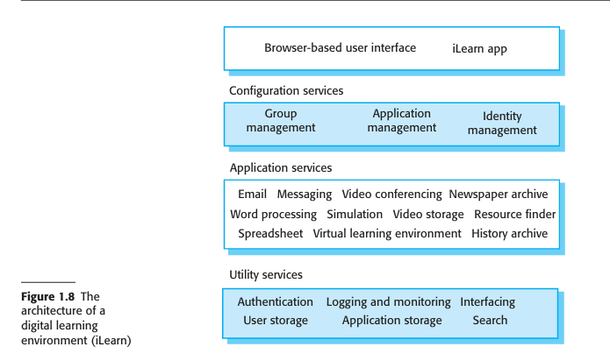

The environment has been designed so that services can be replaced as new ser vices become available and to provide different versions of the system that are suited for the age of the users. This means that the system has to support two levels of ser vice integration:
- Integrated services are services that offer an API (application programming interface) and that can be accessed by other services through that API. Direct service-to-service communication is therefore possible. An authentication service is an example of an integrated service. Rather than use their own authentication mechanisms, an authentication service may be called on by other services to authenticate users. If users are already authenticated, then the authentication service may pass authentication information directly to another service, via an API, with no need for users to reauthenticate themselves.
- Independent services are services that are simply accessed through a browser interface and that operate independently of other services. Information can only be shared with other services through explicit user actions such as copy and paste; reauthentication may be required for each independent service.

Chapter 2: software process and model (Study this for essay questions)
What is a software process?
Software process is a set of related activities that leads to the production of software system.

Chapter 3: Agile Development (Study this for essay questions)

Chapter 4: Human aspects of Software Engineering

Chapter 5: Requirements Engineering (Study this for essay questions)

Chapter 6: Requirements Modelling (Study this for essay questions)

Chapter 7: Design Concepts (Study this for essay questions)

Chapter 8: Architectural Design

